Ring Trip
The connection to the CO (Central Office) comprises only 2 wires: Tip and Ring. This connection is called the "Local Loop."
The Tip is positive (+ve) and colored green. The Ring is negative (-ve) and colored Red. In the central office (CO) the ringer generator creates the ringing signal. In the subscriber’s home there is a ring unit which is the device to alerts you to an incoming call. Originally, the ringer was a electromagnetic bell. Today, most ringers are electronic devices.
To ring the telephone the Central Office sends the following:
- a 90 to 120 VAC ringing voltage
- Frequency of 20 Hz
- Cadence for North America is 2 sec On/ 4 sec Off

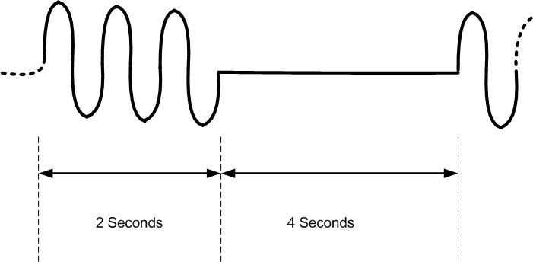
Figure 1: Ring Cadence for North America

Ring trip occurs when the subscriber hears the telephone ringing and picks up the receiver which is called hook switch.
Hook Switch
The hook switch is activated by lifting the handset off of the cradle. The position of the hook switch determines whether the telephone is waiting for a call (on hook), or is actively using the line (off-hook). The off-hook position informs the network of a request for use. The on-hook position releases the use of the network.
Ring Trip

When the subscribers answers the telephone and generating hook switch it could be during the 2 seconds of ringing or the 4 seconds of silence. There is a 33.3% chance the phone will be picked up during the ringing cycle (2/6 seconds), whereas there is a 66.7% change of picking up the phone during the ring cadence (4/6 seconds).

If the phone is picked up during the ringing cycle phone is picked up during the ringing cycle (33.3%) it could be picked up at the top of the ring cycle (Vmax) or at the bottom of the sine wave of the ringing (Vmin). See Figure 3 for the location of Vmax and Vmin.

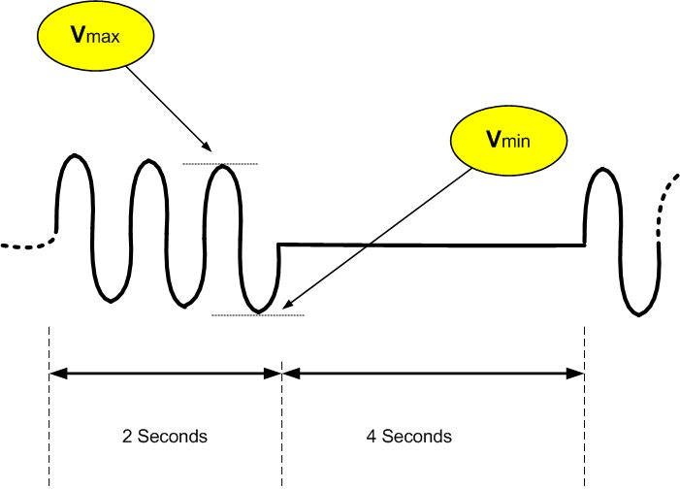
Figure 2: Vmin and Vmax Ringing Voltages

Recall that the ring generator uses a 90 – 120 Volt AC ring generator with a 20 Hz frequency.

If the DC voltage is 48 V and the AC Voltage is 75 Veff, than the maximum (peak) voltage on the copper pair is 48 + 75 x SQRT(2)= 154 V (peak).

During this 33.3% probable event of the subscriber picking up during the ringing cycle, there is an even smaller chance that the pickup could occur during the 154 Volt peak.

If the subscriber is unlucky enough to be hit by the 154 Volt peak energy will flood the ADSL AFE (Analog Front End) circuit causing the modem to loose packets. This peak is reduced in energy by the resistance of the local loop.

Ring trip is therefore a bigger problem with short loops rather than long loops. It is the short loops of less than 9,000 feet (2,740 m) where we run the triple plan of voice, data and video. A small packet loss with a surf the Internet account is repaired quickly with the TCP/IP protocol.
However, with video there is no time to re-transmit lost packets. These ring trip packet losses result in video pixelization.

Ringing Events

Most Ring Generators start the sine wave ringing cycle at the zero cross as shown in Figure 2. Some ring generators are a non-zero cross and can cause a spike of energy at the start and possibly at the end of each 2 second ringing cycle.

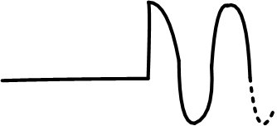

Figure 3: Non Zero Cross Ring Generator

Engineering Best Practices

There are two solutions to deal with ringing and ring trip events. One is to increase the SNR on the DSL circuits to 8 dB. The other is for
video applications under 9,000 feet the video pixelization can be addressed by absorbing the ring trip energy. The Wilcom PS-11-RTM provides this solution at the subscriber NID (Network Interface Device).
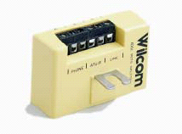

Figure 4: PS-11-RTM CPE Master Splitter

Wilcom
P.O. Box 508, Laconia, NH 03247
Tel: 603/524-2622 • Fax: 603/524-3735
www.wilcominc.com

